**RT-HaND_I SOP work instructions for maintenance and growth of the database: Pre-EPIC Cohort**

**Introduction**

As of 4/10/23 (the date to which the retrospective cohort data is up-to-date currently), around 50% of patients in the cohort were still alive. Future imaging data for these patients will also therefore require curation, ingestion and storage within RT-HaND_I in XNAT. This can include further imaging from PACS or Radiotherapy Treatment from Aria. The same methodologies as the initial ingestions of these patients data can mostly be employed and are detailed below.

1. **Updating from PACS**

To update the lake for previous retrospective patients, PACS should be queried for new studies since the last ingestion (using a date filter based on the last date that PACS was queried for these patients). Of note for both PACS ingestion and Aria ingestion, the dates used for ingestion should overlap so that no scans are missed. XNAT does flag to the user if ingested scans are identical to previous scans (name and UID) and extra studies can easily be deleted.

The descriptions should be used to select the studies for ingestion. There is a list of agreed *include* and *exclude* studies to use to initially filter the list. This can be found in 012a: Imaging Study Descriptions known Include vs Exclude criteria. It is likely that not all study descriptions will be included on either the *include/exclude* list. This is due to updates in scanning protocols and new machines. A clinician should be consulted regarding the new study descriptions and the *include/exclude* lists updated accordingly. With imaging studies to be ingested filtered out, CSC can then ingest via REST-API with access to the PACS-XNAT pipeline given with respect to clinical priorities.

Patients known to be deceased should not be included in this query. A data extract from EDW can confirm known deceased patients.

The basic flowchart for this querying process is shown in Figure 1.

RT-HaND- 011 Transfer of Imaging Data SOP details how the data availability document should be updated accordingly after ingestion.

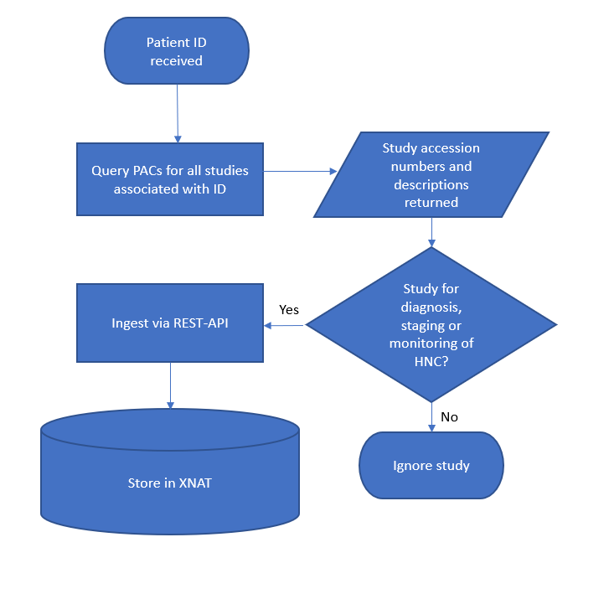

Figure 1: PACS ingestion flowchart

1. **Updating from Aria**

To update the lake for previous retrospective patients, Aria should be queried for new studies since the last ingestion (using a date filter based on the last date that Aria was queried for these patients). The studies should then be named according to RT-HaND-013 Transfer of Radiotherapy Data SOP and ingested into XNAT.

In the ingestion of the retrospective cohort most patients were treated in Mosaiq and so details on their prescription, completed fractions and radiotherapy start and end dates were taken from EDW and stored within RT-HaND_C in EDW as this is treatment information. The patients treated through Aria had this data manually compiled.

Valuable data taken from Mosaiq previously as per RT-HaND 007a-HaND_C Retrospective Data Dictionary were:

|  |  |  |  |  |
| --- | --- | --- | --- | --- |
| Data label | Description | Primary Data source | Data type | Coding |
| HNCRT | Head and Neck Cancer Radiotherapy | Mosaiq | String | "0" = No, "1" = Yes, "Historic" = RT at GSTT pre-2010, "Elsewhere" = RT at another centre |
| HNCRT_course_1_site | Head and Neck Cancer Radiotherapy Course 1 Site | Mosaiq | String | Free text |
| HNC_RT_course_1_site_details | Head and Neck Cancer Radiotherapy Course 1 Site details | Mosaiq | String | Free text |
| HNC_RT_course_1_intent | Head and Neck Cancer Radiotherapy Course 1 Intent | Mosaiq | String | "Radical", "Palliative", didn't receive RT = "Not applicable" |
| HNC_RT_course_1_category | Head and Neck Cancer Radiotherapy Course 1 Category | Mosaiq | String | Free text; "NULL" = missing data |
| HNC_RT_course_1_technique | Head and Neck Cancer Radiotherapy Course 1 Technique | Mosaiq | String | Free text (e.g. VMAT), ; "NULL" = missing data, didn't receive RT = "Not applicable" |
| HNC_RT_course_1_energy | Head and Neck Cancer Radiotherapy Course 1 Energy | Mosaiq | String | Free text (e.g. 6 MV), ; "NULL" = missing data, didn't receive RT = "Not applicable" |
| HNC_RT_course_1_px_point | Head and Neck Cancer Radiotherapy Course 1 Prescription Point | Mosaiq | String | Free text (e.g. MPD), ; "NULL" = missing data, didn't receive RT = "Not applicable" |
| HNC_RT_course_1_dose_per_Fr | Head and Neck Cancer Radiotherapy Course 1 Dose per Fraction | Mosaiq | Float | Numeric value (Gy); "NULL" = missing data, didn't receive RT = "Not applicable" |
| HNC_RT_course_1_recorded_total_dose | Head and Neck Cancer Radiotherapy Course 1 recorded Total Dose | Mosaiq | Float | Numeric value (Gy); "NULL" = missing data, didn't receive RT = "Not applicable" |
| HNC_RT_course_1_recorded_fractions | Head and Neck Cancer Radiotherapy Course 1 recorded Number of Fractions | Mosaiq | Integer | Numeric value; "NULL" = missing data, didn't receive RT = "Not applicable" |
| HNC_RT_course_1_initially_intended_total_dose | Head and Neck Cancer Radiotherapy Course 1 initially intended Total Dose | Mosaiq | Float | Numeric value (Gy); "NULL" = missing data, didn't receive RT = "Not applicable" |
| HNC_RT_course_1 _initially_intended_fractions | Head and Neck Cancer Radiotherapy Course 1 initially intended Number of Fractions | Mosaiq | Integer | Numeric value; "NULL" = missing data, didn't receive RT = "Not applicable" |
| HNC_RT_course_1_start_date | Head and Neck Cancer Radiotherapy Course 1 Start Date | Mosaiq | Date | Date: DD-MM-YYYY; "NULL" = missing data |
| HNC_RT_course_1_end_date | Head and Neck Cancer Radiotherapy Course 1 End Date | Mosaiq | Date | Date: DD-MM-YYYY; "NULL" = missing data |
| HNC_RT_course_1_elapsed_time | Head and Neck Cancer Radiotherapy Course 1 Elapsed Time | Mosaiq | Integer | Numeric value (days); "NULL" = missing data, didn't receive RT = "Not applicable" |
| HNC_RT_course_1_replans | Head and Neck Cancer Radiotherapy Course 1 Re-plan | Mosaiq | String | Numeric value (number of replans); "NULL" = missing data, didn't receive RT = "Not applicable" |
| HNC_RT_course_1_planning_MRI | Head and Neck Cancer Radiotherapy Course 1 planning MRI | Mosaiq | String | 0="No", 1="Yes"; "NULL" = missing data, didn't receive RT = "Not applicable" |
| HNC_RT_course_1_interruption | Head and Neck Cancer Radiotherapy Course 1 interruption | Mosaiq | String | 0="No", 1="Yes"; "NULL" = missing data, didn't receive RT = "Not applicable" |
| HNC_RT_course_1_interruption_reason | Head and Neck Cancer Radiotherapy Course 1 interruption reason | Mosaiq | String | Free text; "NULL" = missing data, didn't receive RT = "Not applicable" |
| HNC_RT_course_1_early_termination | Head and Neck Cancer Radiotherapy Course 1 early termination | Mosaiq | String | 0="No", 1="Yes"; "NULL" = missing data, didn't receive RT = "Not applicable" |
| HNC_RT_course_1_early_termination_reason | Head and Neck Cancer Radiotherapy Course 1 early termination reason | Mosaiq | String | Free text; "NULL" = missing data, didn't receive RT = "Not applicable" |
| HNC_RT_course_1_High_dose_volume_dose | Head and Neck Cancer Radiotherapy Course 1 High dose Volume dose | Mosaiq | String | Free text; "NULL" = missing data, didn't receive RT = "Not applicable" |
| HNC_RT_course_1_Ppx_dose_volume_dose | Head and Neck Cancer Radiotherapy Course 1 Ppx dose Volume dose | Mosaiq | String | Free text; "NULL" = missing data, didn't receive RT = "Not applicable" |
| HNC_RT_course_1_RT_clinical_trial | Head and Neck Cancer Radiotherapy Course 1 RT clinical trial | Mosaiq | String | Free text; "NULL" = missing data, didn't receive RT = "Not applicable" |
| HNC_RT_course_1_RT_clinical_trial_details | Head and Neck Cancer Radiotherapy Course 1 RT clinical trial details | Mosaiq | String | Free text; "NULL" = missing data, didn't receive RT = "Not applicable" |
| HNC_RT_course_1_Previous_relevant_RT | Head and Neck Cancer Radiotherapy Course 1 Previous relevant RT | Mosaiq | String | Free text; "NULL" = missing data, didn't receive RT = "Not applicable" |
| HNC_RT_course_1_Previous_relevant_RT_details | Head and Neck Cancer Radiotherapy Course 1 Previous relevant RT details | Mosaiq | String | Free text; "NULL" = missing data, didn't receive RT = "Not applicable" |
| HNC_RT_course_1_pacemakerICD | Head and Neck Cancer Radiotherapy Course 1 pacemakerICD | Mosaiq | String | Free text; "NULL" = missing data, didn't receive RT = "Not applicable" |

Currently CSC are trying to connect Aria’s database containing this prescription and treatment information to a similar warehousing system so that these radiotherapy details do not need to be complied manually. The database containing these radiotherapy details is called “AURA”. Eclipse scripting is another potential method that could locate a lot of these pieces of data to minimise manual data curation in future. Whilst some of these pieces of data is contained within the radiotherapy treatment plans themselves, some will be of important use for research later such as the start and end dates to calculate the elapsed time to make EQD2 dose calculations and so locating this data in an automated fashion is an important consideration for moving forwards.